Graehme Blair

ghb130

EECS 355

Lab 1: Calculator

Simulation Results

Two simulations were applied, one 8 bit and one 16 bit. Numbers/Ops were read in from a text file using I/O in the test bench and then passed to the calculator component.

8 Bit Simulation:

Input: Output:

12

12 + 4 = 16

12 \* -4 = -48

12 - 4 = 8

-5 + 5 = 0

0 \* 5 = 0

4

+

12

-4

\*

12

4

-

-5

5

+

0

5

\*

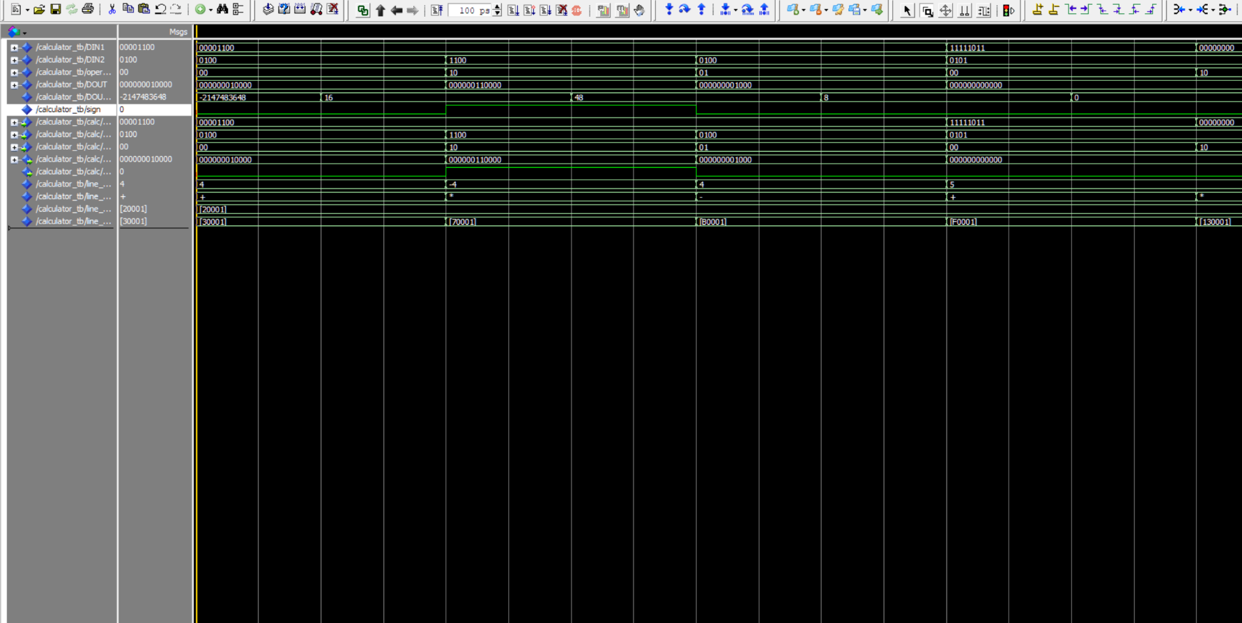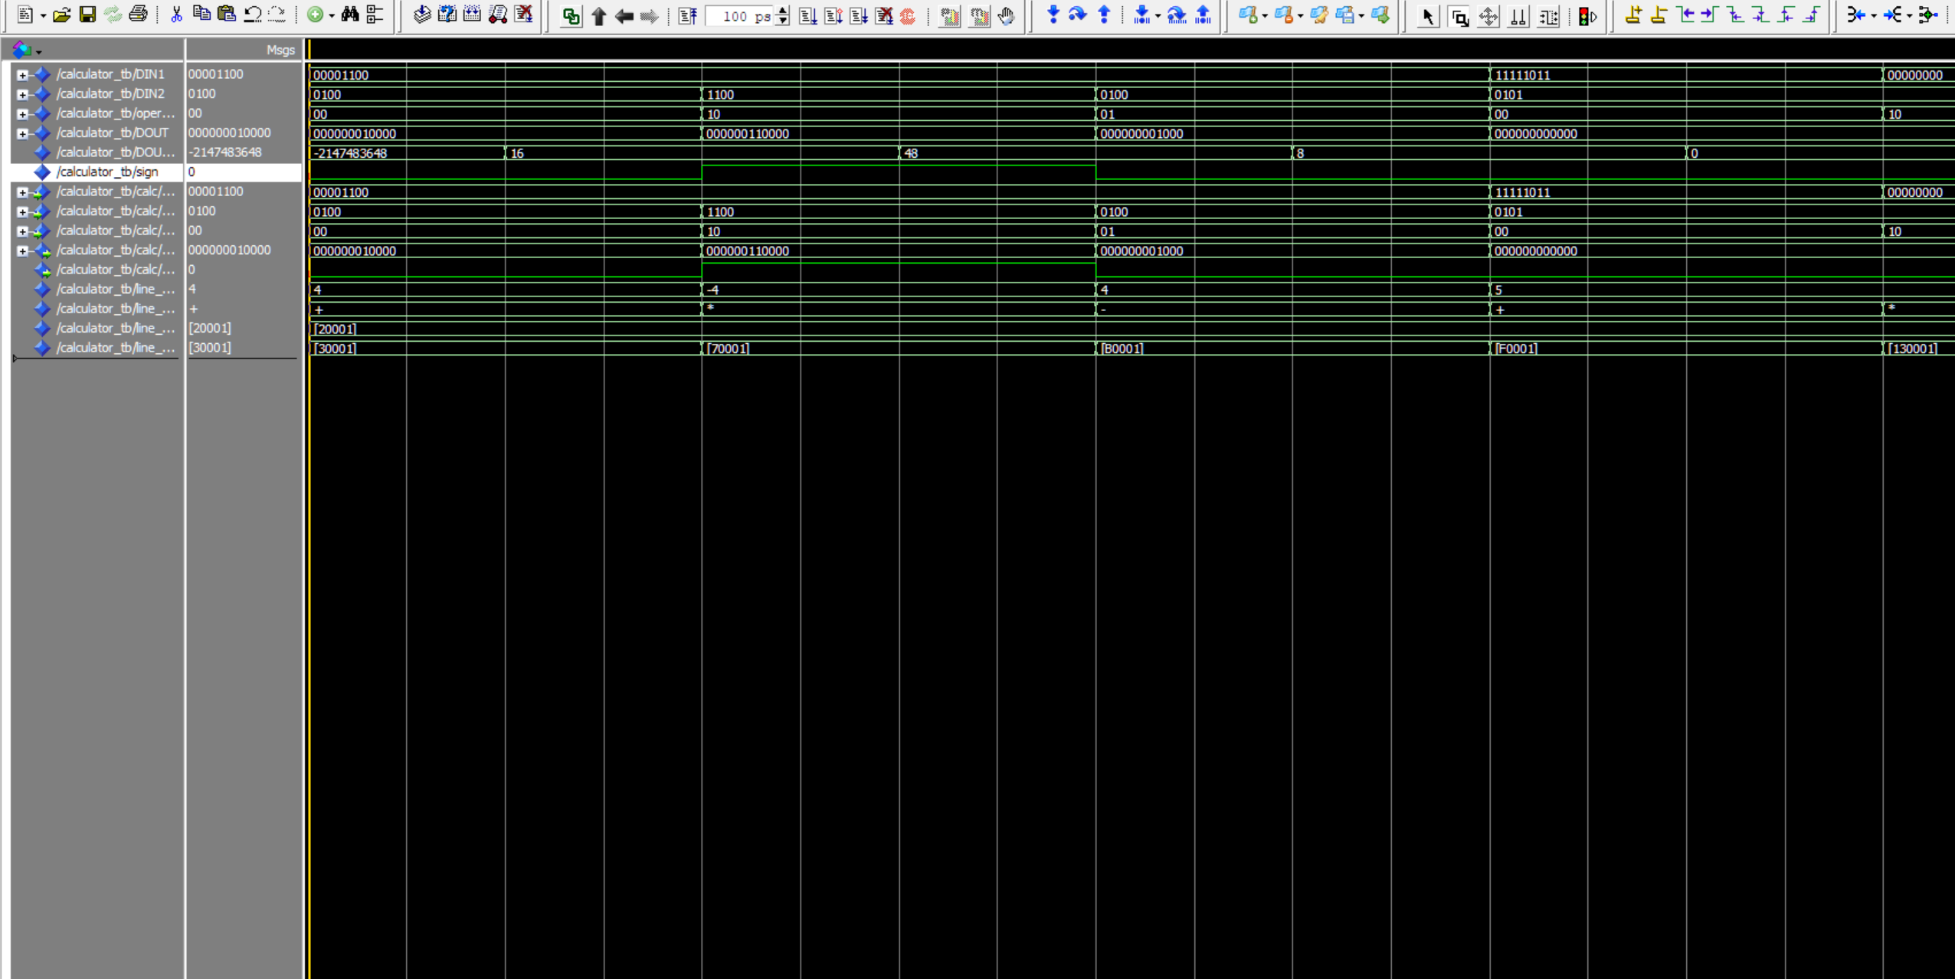Waveform:

16 Bit Simulation:

Input: Output:

122

122 + 89 = 211

1234 \* -10 = -12340

1356 - 86 = 1270

-120 + -40 = -160

-333 \* 3 = -999

10 - 80 = -70

89

+

1234

-10

\*

1356

86

-

-120

-40

+

-333

3

\*

10

80

-

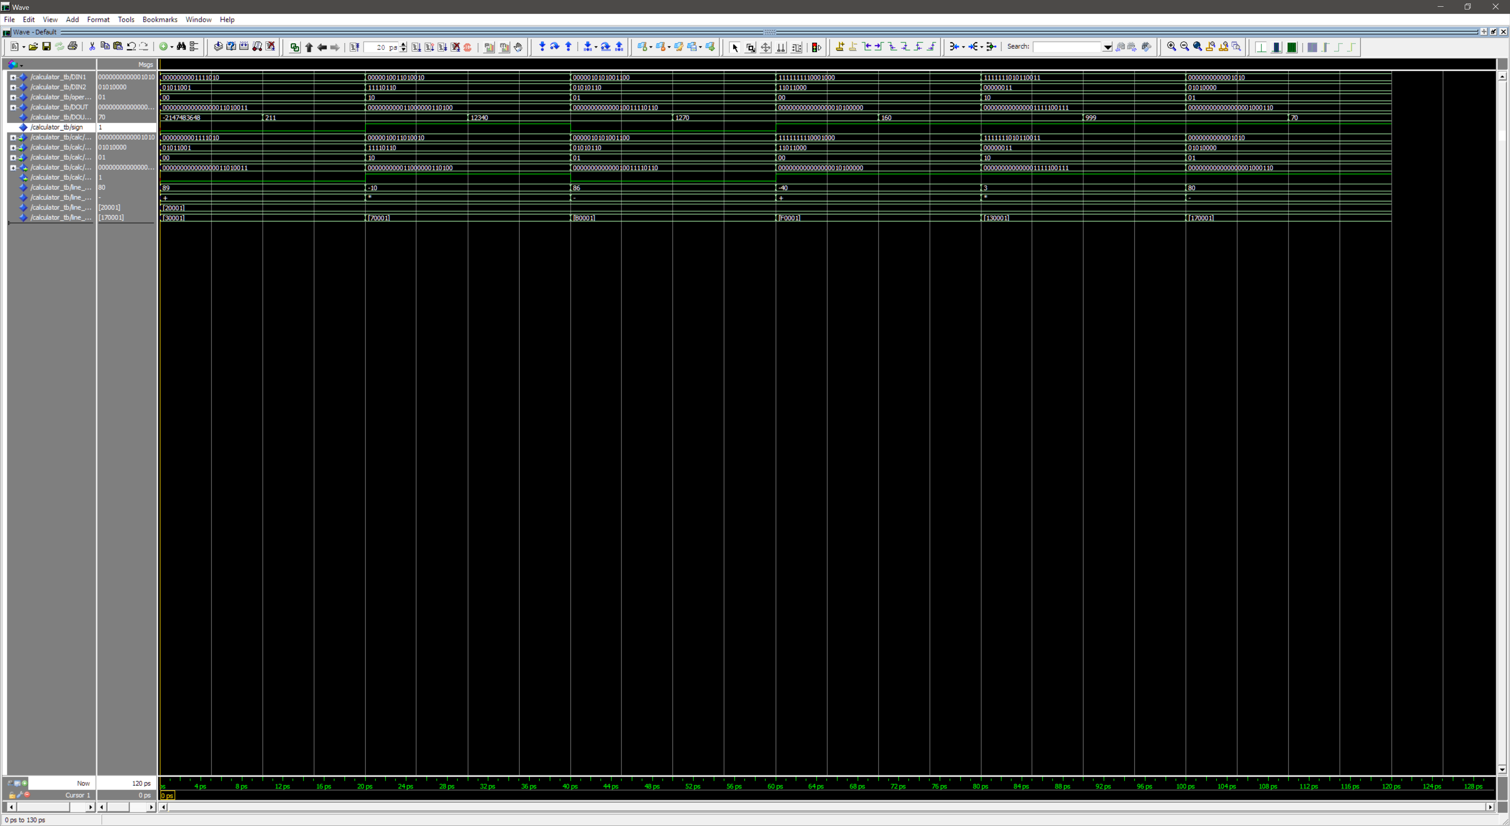Waveform: